
Retrieved 7/28/2024:
https://misiones.cubaminrex.cu/en/articulo/different-sectors-north-american-society-urge-us-government-request-cuban-doctors-and

Different sectors of North American society urge U.S. Government to request Cuban doctors and Interferon
APR
14
2020

Historic People's Appeal Calling For Cuban Medical Personnel To Help Eradicate COVID-19/SARS-COV-2 on US Soil

In loving memory of cultural icons Manu Dibango, Ellis Marsalis and Bill Withers.
Also dedicated to The New York Assemblyman Charles Barron and Councilwoman Inez Barron both lifetime friends and supporters of Cuba, currently recovering from the COVID-19 Pandemic.

Embracing Cuba’s Heroic Efforts To Eradicate The Corona Virus(COVID-19/SARS-COV-2)

After learning that the United States of America, officially confirmed that they have overtaken China and Italy with the most cases of the Coronavirus(COVID-19/SARS-COV-2), this fatal news will result in an increased level of panic, anger and uncertainty.

Because this alarming news coincides with a statement from the White House, that parts of the nation’s labor force could be returning to work, everyday families and communities appear open to receiving assistance from quarters regardless of additional factors beyond the realm and parameters of health and medicine.

For that reason, a very interesting dynamic to watch very carefully is how people living inside US borders who have relatives and friends that have either contracted or tragically succumbed to the virus, respond when they discover that France and Italy(two trusted US NATO allies) decided, that they do not have the luxury of either rejecting or ignoring assistance from the Government of Cuba to fight the COVID-19/SARS-COV-2 on the shores of their nations.

While confined to their homes glued to their televisions, computers and cellphones, families and communities inside US Borders have witnessed, A French Parliamentary Leader Andre Chassaigne urging his Government to join those who have requested Cuban support, and 52 Cuban Doctors and Nurses arrive in Italy to treat their citizens who have contracted the COVID-19/SARS-COV-2 pandemic. These developments come on the heels of the Governments of Great Britain and Northern Ireland reaching a diplomatic agreement with Cuba, which resulted in a cruise ship(MS Breamar of the Fred Olsen cruise line)docking on their shores where established health measures were successfully implemented. The actions taken by Cuban medical personnel were in compliance not only with their Ministry of Public Health, but the World Health Organization(WHO).

These breakthroughs and developments, have created a climate and atmosphere for truth and justice seekers, to reflect on what transpired inside US borders back in 2001 during 9/11 and Hurricane Katrina in 2005. The Cuban Government offered to send Medical personnel to New York City immediately after the 9/11 attacks, and four years later offered to deploy 1,500 Medical personnel to the Gulf Region after Hurricane Katrina, who would have remained there until the public hospitals were back to their normal function.

For that reason, an aggressive blend of history, morality and integrity push us to emphatically demand the following.

1. Urge The White House, US Congress and US Senate grant the Henry Reeves Medical Brigade(Cuban Medical Personnel) permission to deploy an emergency brigade to immediately come to US Borders to provide hands on Medical Assistance in Hospitals, Clinics and other emergency installations.

2. Urge The White House, US Congress, and US Senate grant Henry Reeves Medical Brigade(Cuban Medical Personnel) permission to deploy an emergency brigade to immediately come to US Borders to conduct hands on training to US Medical personnel, whose experience dealing with the pandemics like COVID-19/SARS/COV-2 is limited.

3. Urge The White House, US Congress, and US Senate grant the American Medical Association, National Medical Association, Black Nurses Association permission to work in conjunction and harmony with the Henry Reeves Medical Brigade(Cuban Medical Personnel), once they arrive on US Soil to assist in the fight to eradicate the COVID-19/SARS/COV-2.

4.Urge The White House, US Congress and Senate to allow COVID-19/SARS/COV-2 Victims on US Soil, Access to Interferon Alpha 2B, which was developed by Cuba's Center for Genetic Engineering and Biotechnology. This measure would be a step in concert with the other 45 Nations worldwide who have made a formal request for Interferon Alpha 2B, based on its proven effectiveness as a form of treatment.

An extended and heartfelt thank you and special acknowledgement of Banbose Shango Retired National Co-Chair National Network On Cuba, AAPRP GC, Zaki Baruti Universal African American Peoples Organization, Brother Jermaine Shabazz Foundation Of Black America Outreach/Social Media Liason, Reverend Marjani Dele and Empress Phile Chinonesu Founder President General of the National Million Women's March and Universal Movements, Mr. Jorden Giger, Mr. J. Kweeku Lumumba of Konbit Sitwayen Sosyalis Pou Sove Ayiti for their distribution of this groundbreaking appeal to their networks and supporters, and Professor Fahima Seck for media outreach. A very special thank you to Reverend Dr. Joan Brown Campbell and Reverend Dr. Albert M. Pennybacker for their strategic advice, encouragement and access to some invaluable contacts. A special thanks and appreciation to Ms. Tejvir Grewall for the crucial role that she played in the outreach process. Lastly a warm and loving thank you to Dr. Lucille Norville Perez, for sharing her insight and wisdom, concerning how appeals and resolutions can be utilized as vehicles for fundamental change.

Endorsements

Organization Of African Doctors
Latin American School Of Medical Sciences
Havana, Cuba

Dr. Lucille Norville Perez
Former President National Medical Association
Washington DC

Dr. Abdul Alim Muhammad
Director
Abundant Life Health Attainment Center
Mitchellville, MD

Reverend James Winkler
President/General Secretary
National Council Of Churches

Reverend Dr. Joan Brown Campbell
Former General Secretary
National Council Of Churches

Chautauqua Institute
Department of Religion

Reverend Dr. Albert M. Pennybacker
Former Assistant Secretary General
National Council Of Churches
Retired Senior Pastor
University Christian Church
Fort Worth, Texas

The Honorable Samia Yaba Nkrumah
Kwame Nkrumah Pan African Center
Accra, Ghana
State Senator

The Honorable Malika Sanders Fortier
Alabama State Senate
District 23

The Honorable Calvin Hawkins
City Council At Large
Prince George’s County Maryland

The Honorable Cynthia McKinney PH D
Former Congresswoman
US House Of Representatives
Georgia’s 11th District

Nana Kwado Boafo(Reverend Willie Wilson)
Pastor Emeritus
Union Temple Baptist Church
Washington DC

Pastor Graylan Ellis-Hagler Senior Pastor
Plymouth Congregational United Church Of Christ
Washington DC

Reverend Dr. Madeline McClenney
Exodus Foundation
Charlotte, North Carolina

US National Network On Cuba
Friendship And Solidarity

Mr. Walter Lippmann
Editor In Chief
Cuba News

The Honorable Alice Windom
1st Wave Of African Americans Repatriates To Ghana
St Louis, Missouri

Dorie Ladner, Mukasa Dada(Formerly Willie Ricks)
Distinguished SNCC Alum

Ms. Aida Rodriguez
Actress, Producer, Writer, Commentator
Los Angeles, California

Mumia Abu Jamal
MOVE Supporter and Defender
Former President Philadelphia
Association Of Black Journalists
US Prisoner At War

Russell Maroon Shoatz
Former Black Panther/Author of Maroon The Implacable
US Prisoner At War

Mr. Jim Lafferty
Executive Director Emeritus
National Lawyers Guild
Alliance For Global Justice
USA

Mr. Damani Aquil
Regional Council
For Africans In The Americans

Mr. Zaki Baruti
Universal African American People’s Organization
St Louis Missouri

Dr. Leonard Jeffries
President Of World African Democratic Union
USA

A-APRP
All African Peoples Revolutionary Party

Dr. Gale Frazier
National Black Agenda Consortium
USA

Mr. Maurice Carney
Executive Director
Friends Of The Congo

Kwame Wildon Wilburg
Friends Of The Congo
National Board Member

Sis. Ama Mazana Ph D
Afrocentricity International
Philadelphia Pennsylvania

Mr. Bokar Ture
Pan African Council
Paris, France

Molefi Asante PhD
Temple University
Philadelphia, Pennsylvania

Bernida Thompson PhD
Director and Founder Roots Activity Learning Center/Roots Public Charter School
Washington DC

Chenzira Davis-Kahina PhD
Per Ankh M Smai Tawi
Virgin Islands Caribbean

Kelly Harris PhD
Director of Africana Studies
Seton Hall University
New Jersey

Greg Carr PhD
Department Of Afro American Studies
Editor In Chief, The Compass,
Association For The Study Of Classical African Civilizations
Washington DC

Robert White Ph D
Professor Department Of Criminal Justice/Department Of Political Science
Alabama State University
Montgomery, Alabama/Senior Pastor Montgomery City Of Refuge

Sandy Placido PhD
Assistant Professor
History Department
Queens College, CUNY
Dominican Studies Scholar
CUNY Dominican Studies Scholar
The City College Of New York

Anthony Browder PhD
Director of IKG Cultural Resources
ASA Restoration Project
Washington DC

Marc Lamont Hill PhD
Professor of Media Studies and Urban Education
Temple University
Philadelphia, Pennsylvania

Isaac Saney Ph D
Director & University Teaching Fellow
Transition Year Program
Dalhousie University & Adjunct Professor
Department History St Mary’s University
(For Identification Purposes Only)
Canada

Professor Fahima Patricia Seck
MSW, LISW

Cecile Johnson
CEO African Development Plan
Human Rights Defender
International Law Professor
Afro Descendant Institute Of Human Rights
Co-Facilitator
Afro Descendant Nation
Confederated USA
Chicago, Illinois

Ms. Kadija George
General Secretary
African Writers Abroad
England

African Awareness Association
Richmond Virginia

Mr. Omowale Adewale
GrassRoots Artists Movement
New York, New York

Attorney Faya Rose Toure
Committee Chair
SOS Movement For Justice and Democracy
Selma, Alabama

Mr. Gerald Pereira
Organization For The Victory Of The People Of Guyana
Guyana, South America

Riba Kelsey M.D.
Atlanta, Georgia

Dr. Malik Shabazz
Author/Attorney/Organizer

Malik Yakini
Detroit Activist

Reverend Mark Thompson
Former Host of Make It Plain
XM/Sirius Radio

Sis. Empress Phile Chinonesu
Founder/President General
National Million Woman March and Universal Movements

Sis. Pam Africa
Minister of Confrontation
MOVE Organization
Philadelphia, Pennsylvania

Sis. Ramona Africa
Minister Of Information
MOVE Organization
Philadelphia, Pennsylvania

Munirah El Bomani Chairwoman Pro Tem:
Black Human Rights Campaign
Newark, New Jersey

Shelah Harper
Founder Asia Adams
Save Our Children Foundation

Chairman Fred Hampton Jr
Chairman POCC

Andrew Johnson
Founder The North American Water and Wellness Institute

Imhotep Chinoesu
Founder Men Of Valor

Darryl Jordan
Director EMEAC/Cass Commons
Detroit, Michigan

Angela Sayles
IFounder
The Institution Of Financial Unity

J. Kweeku Lumumba
Konbit Sitwayen Sosyalis Pou Sove Ayiti(Socialists Citizens Working Together To SAve Haiti)
External Relations Coordinator

Attorney Ezili Danto
Haitian Lawyers Leadership Network

Mr. Joe Beasley
Joe Beasley Foundation/Southern Regional Director
of Rainbow Push Coalition, Emeritus

Bilal Sunni Ali
Southern Artists Media Education Connection Association

Norma Jackson PhD
President World Development Alliance
Columbia, South Carolina

Carolina Peace Resource Center
Columbia, South Carolina

Mr. Justin Figueroa
President Fig Tree Foundation
Newark, New Jersey

Wilmer Leon Ph D
XM/Satellite Radio
Inside The Issues
Washington DC

Willie and Mary Racliff
Publisher and Editor
San Francisco BayView Newspaper
San Francisco, California

Mr. Rock Newman
Executive Producer and Host
Of The Rock Newman Show
WHUT Howard University
Washington DC

DJ BuddyFolks
What Good Is A Song?
The Friday Night Drum
WRFG Atlanta, Georgia

Mr. Louis Wolf
Co Author and Co Publisher
Covert Action Magazine
Washington DC

Mr. Sam P.K. Collins MPP
Founder and Host
AllEyesOnDC
Washington DC

Dwann Brown
Radio Host
Hotep-ish
Los Angeles, California

Ms. Ericka Blount Danois
Award Winning Author (Author Of Love Peace and Soul: Behind The Scenes Of America’s Favorite Dance Show Soul Train: Classic Moments)
Baltimore, Maryland

Sankofa HomeSchool Community
Washington DC

Jania Otey Esq
Kids And Culture Camp
Washington DC

Mr. Jay Davis
United Teachers Of Los Angeles
Los Angeles, California

Ms. Esther Iverem
Creator & Executive Producer
On The Ground News Productions
Los Angeles, California

Rabiah Nur
Spring Of Light

Sis. Luci Murphy
Artistic Director
ONE DC
Black Workers Center Chorus

Sis. Elise Bryant
Labor Heritage Foundation

Mr. Sinclair Skinner
Co-Founder
Bilimari INC
Harare, Zimbabwe

Executives For Georgia Green Party
Denice Traina Co Chair
Hugh Esco Secretary
Leroy Bartell Treasurer

Mr. D.A. Blevins
San Diego Urban Warriors INC
San Diego, California

Mr. Anthony Muhammad
Sankofa Youth Development Program Inc
Birmingham, Alabama

Mr. Kwame Osagyefo Kalimara
New Afrikan Peoples Organization/Malcolm X Grass Roots Movement
Georgia Chapter

Ms. Vivian Shaku
House Of Globalization
Atlanta, Georgia

Emmanuel Cannady
Black Lives Matter-South Bend, Indiana

Ms. Cynthia Charles
Billionaire Beauty LLC
Baltimore, Maryland

Dr. Mel Eugene Butler
Maker To Markets LLC

Mr. Kiko Burroughs
Delano Brothers
Trucking LLC
New Jersey

Writing On The Walls
Youth Literacy Program
Washington DC

Mr. Sam Anderson
Cuban Solidarity and Support Pioneer
New York City

Yao Fulmore
Kwanzaa Associate INC
Virginia

Dr. Kelechi Egwim
Exective Director
APPEAL INC
Washington DC

Zahir Muhammad
President of DeMatha High School
Black Student Union

Mr. Roy Ageymang
Director Of The Award Winning Film
Mugabe:Villain Or Hero
London, England

Akua Holt
Pan African Journal / Pacifica Radio

Sandra Izsadore
Author, Activist, Lyricist

Reverend Marjani Dele
Reverend Dele Ministries

Mr. Obi Egbuna Jr
External Relations Officer
Zimbabwe Cuba Friendship Association
Co-Founder Mass Emphasis Children’s History and Theater Company
Washington DC/Harare, Zimbabwe
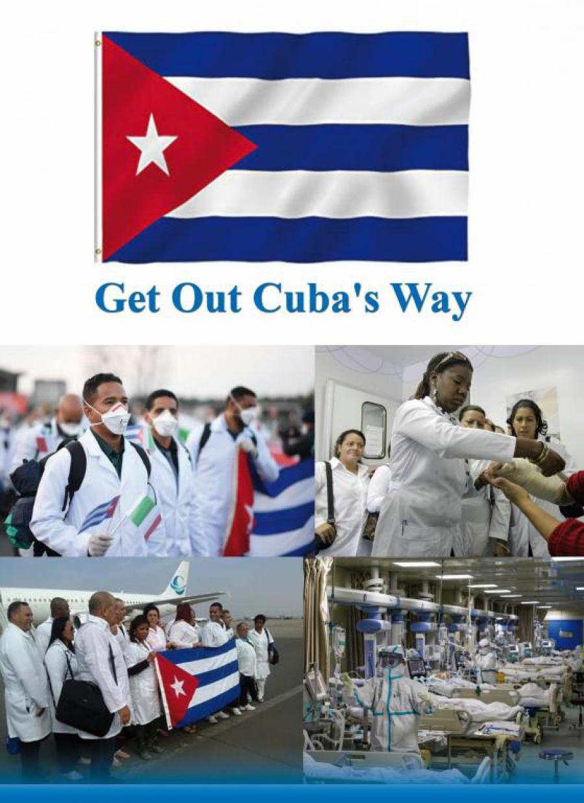
Etiquetas:
#Cuba #EstadosUnidos #COVID19
Categoría:
Situaciones Excepcionales
RSS Minrex:

